ASSIGNMENT 3

|  |  |
| --- | --- |
| Date | 30 October 2022 |
| Team ID | PNT2022TMID18149 |
| Project Name | NUTRITION ASSISTANT APPLICATION |

1. Create a bucket in IBM object storage

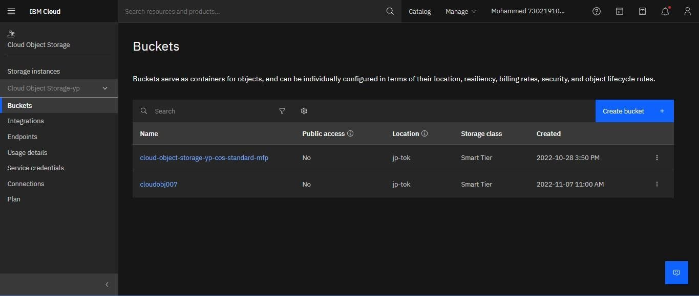

1. Upload 5 images to IBM object storage and make it public. write html code to displaying all the 5 images.

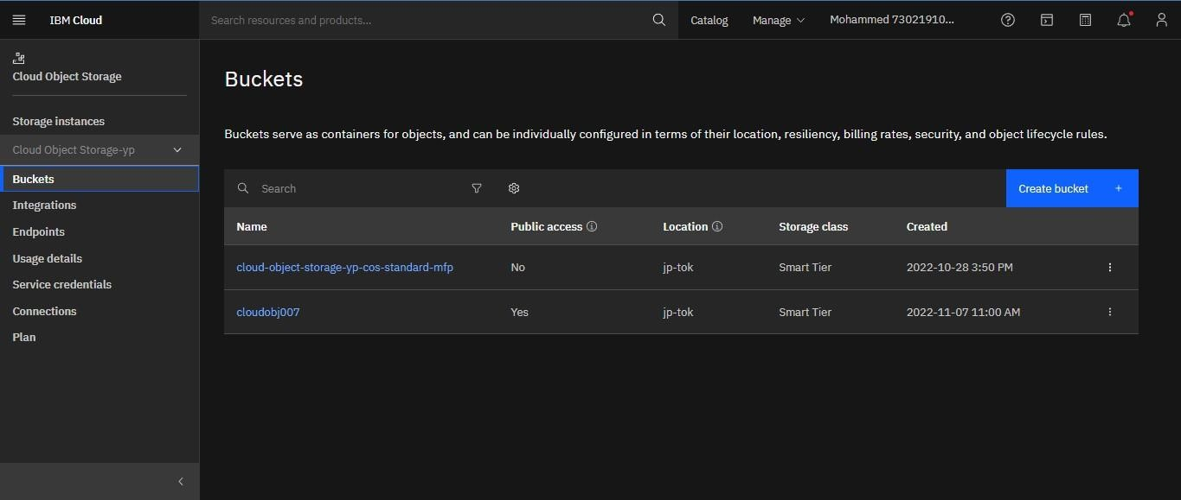

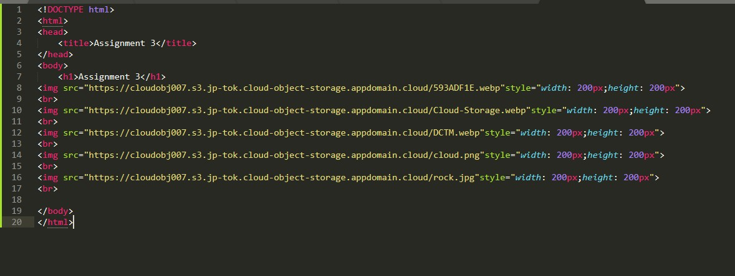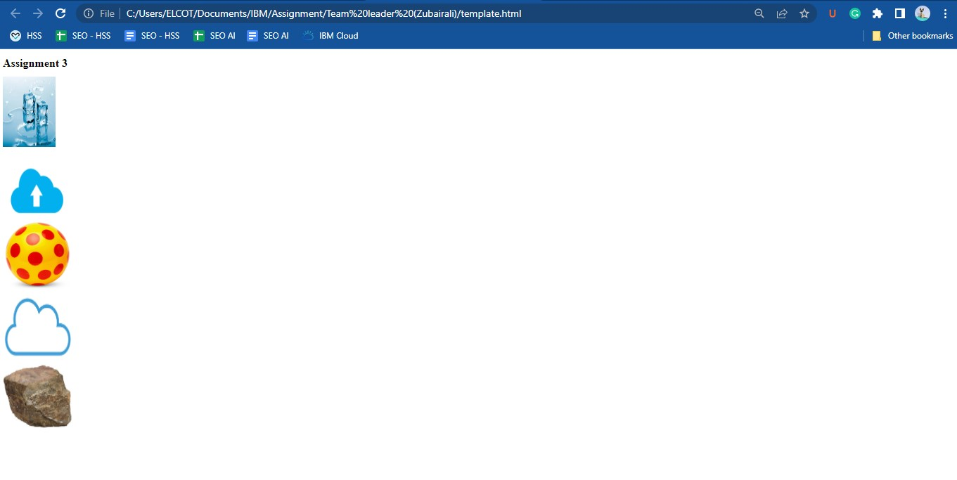

3.Upload a CSS page to the object storage and use the same page in your HTML code.

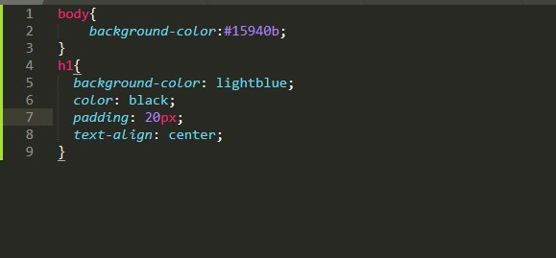

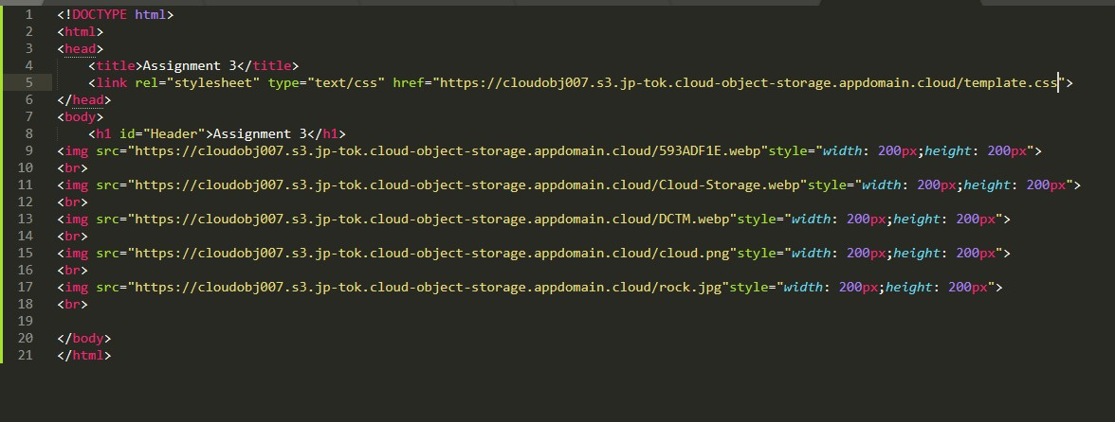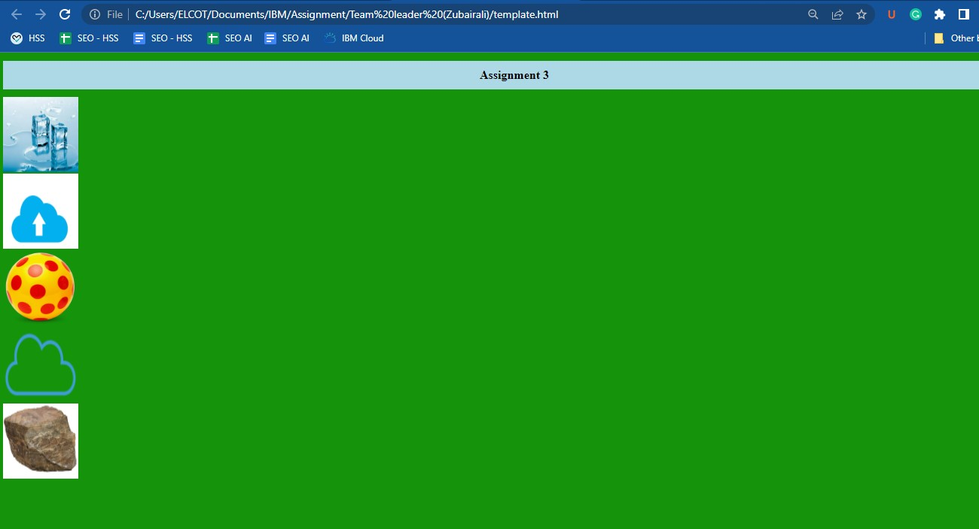

4. Design a chatbot using IBM Watson assistant for hospital. Ex: User comes with query to know the branches for that hospital in your city. Submit the web URL of that chat bot as a assignment. & Create Watson assistant service with 10 steps and use 3 conditions in it. Load that script in HTML page.

